NIP Project — Submission
Pega Platform Project — Movie Ticket Booking Management

Section 1 — Your Details
Full Name | N Femina
Email ID (registered on NIP) | feminaias23@gmail.com
Phone Number | 8778811980
College Name | VSB engineering College Karur
Course (e.g. IT, CS) | CSE
State | Karur
Project Chosen | Movie Ticket Booking
Pega Application Name | Movie Ticket Booking Management
Case Type Name (exact) | Movie Ticket Request
Pega Instance URL | https://8uc9psaq.pegaacademy.net/prweb/app/movie-ticket-booking-management/1O3kfChUoyqPj2zmFwqFq7C8uA6oWcaK*/!OpenPortal_Developer
Operator Name (created in Pega with full name) | feminaias

Section 2B — Movie Ticket Booking Management Application
Completed section for the chosen project — Movie Ticket Booking Management.
US-001 — Submit Movie Ticket Request
What is expected: Case created, customer submits Movie Name, Show Date, Show Time, Number of Tickets. Validation applied.
Screenshot:
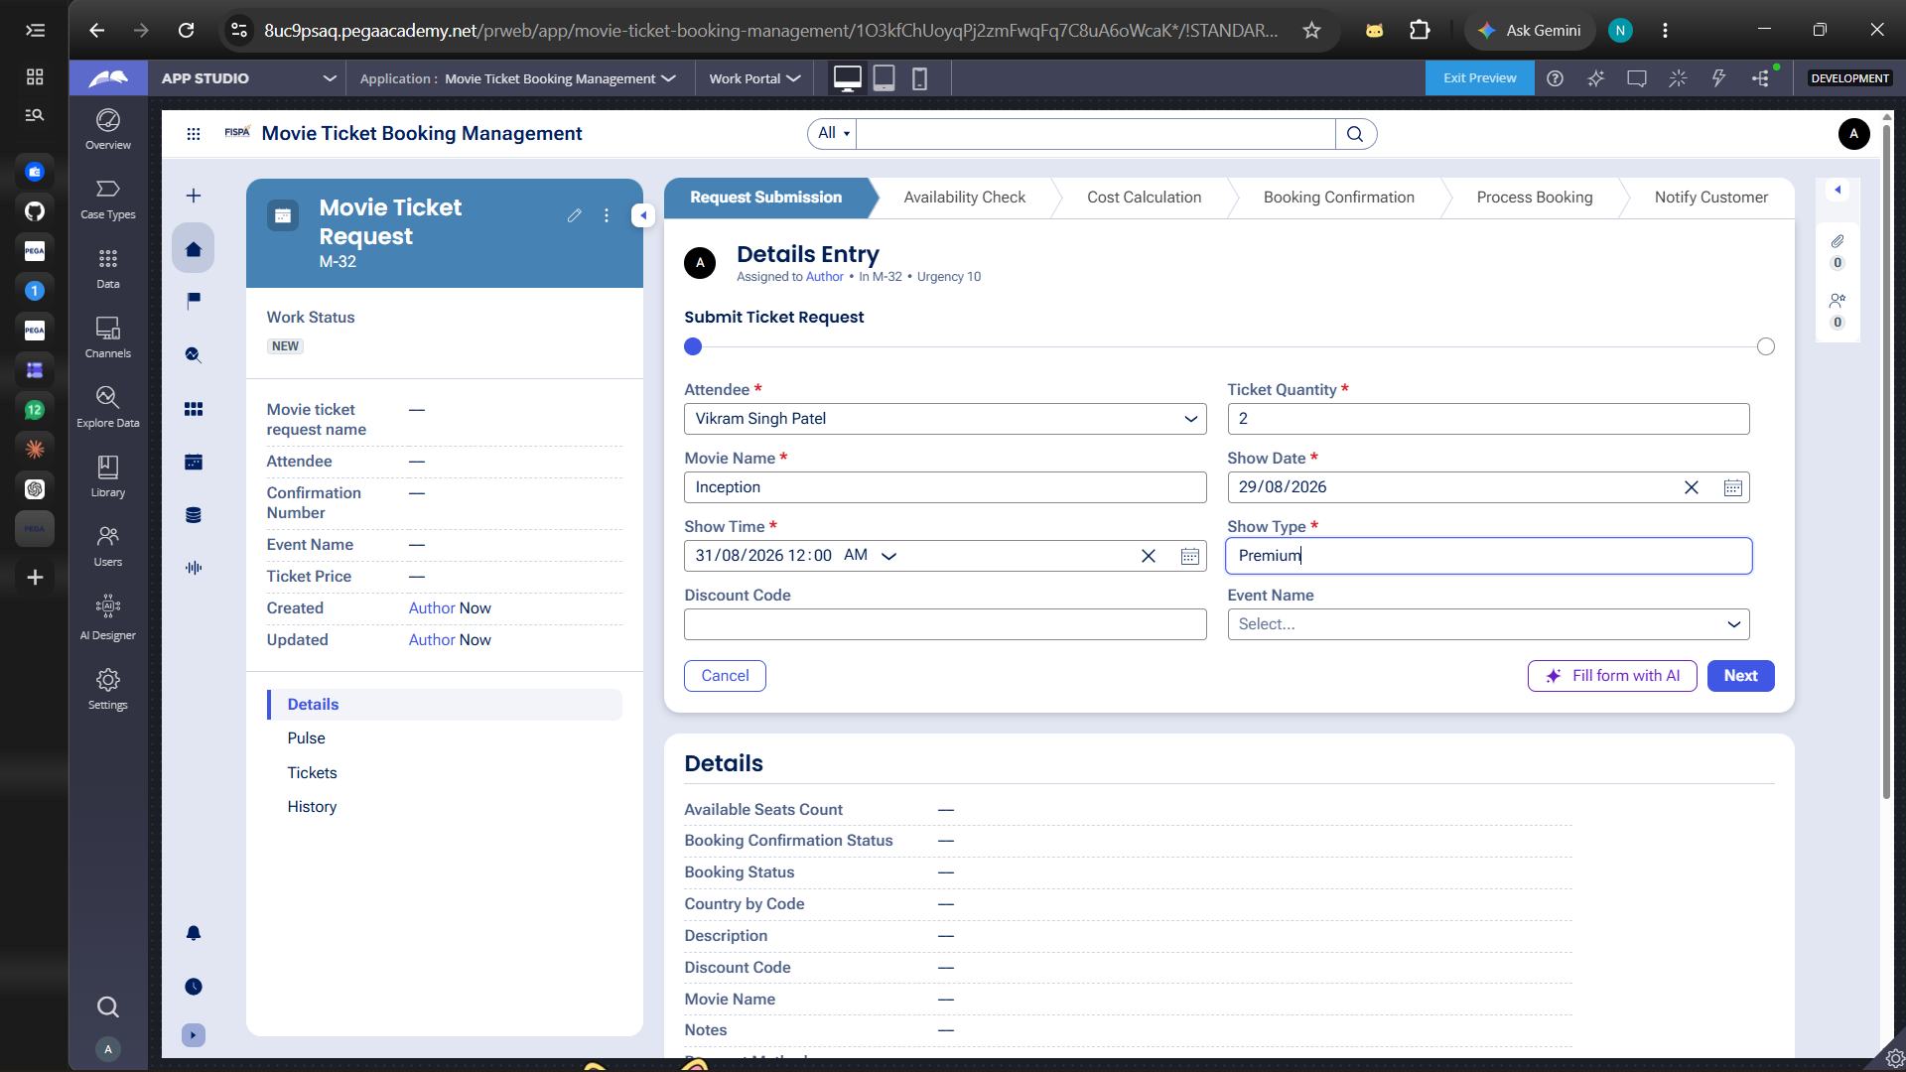
Request Submission screen — Movie Name, Show Date, Show Time, Ticket Quantity and Show Type captured.
What I built for this:
Built the Request Submission form capturing Attendee, Movie Name, Show Date, Show Time, Ticket Quantity, Show Type and Discount Code with required-field validation before the case moves forward.

US-002 — Check Show Availability
What is expected: Availability stage. Seat Availability Status and Available Seats Count captured. Booking proceeds only if available.

Screenshot:
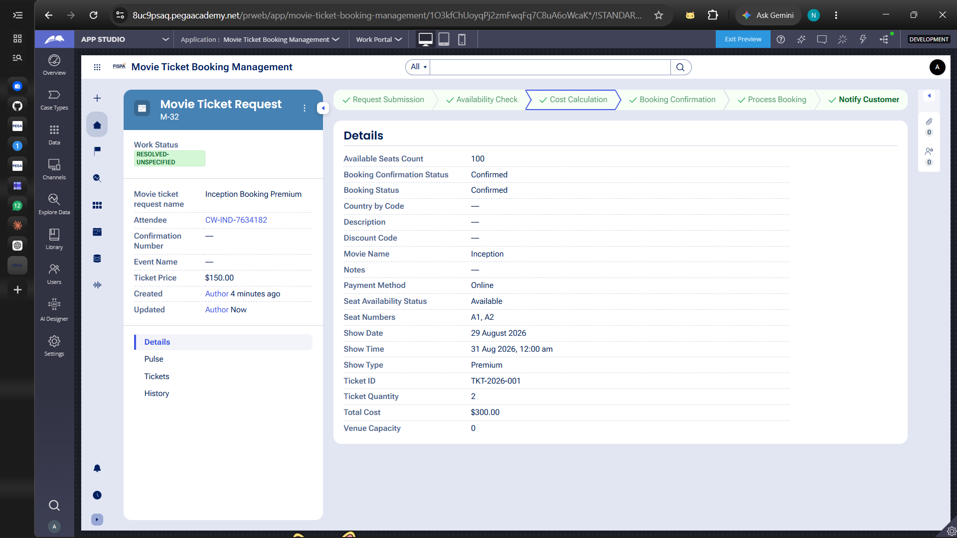
Case details after the Availability Check stage — Seat Availability Status = Available, Available Seats Count = 100.
What I built for this:
Configured the Availability Check stage with Fetch Show Data and Evaluate/Check Seat Availability steps, which populate Seat Availability Status and Available Seats Count before the booking can proceed.

US-003 — Calculate Booking Cost
What is expected: Total Cost calculated automatically from Ticket Price and Number of Tickets using a business rule.
Screenshot:
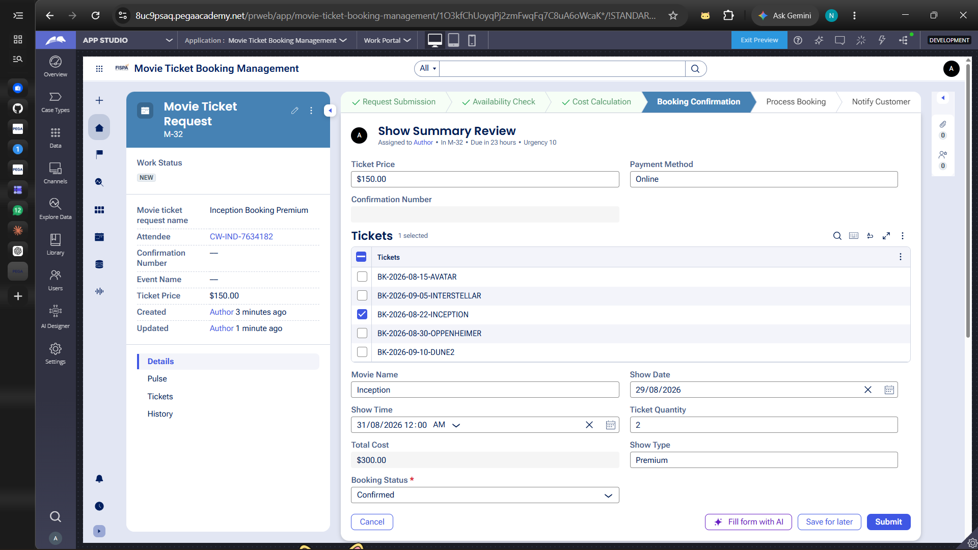
Show Summary Review screen — Ticket Price = $150.00, Ticket Quantity = 2, Total Cost = $300.00, Payment Method = Online.

What I built for this:
Added a Compute Booking Total step in the Cost Calculation stage that derives Total Cost from Ticket Price × Ticket Quantity, shown automatically on the review screen.

US-004 — Confirm Booking Request
What is expected: Approval stage assigned to Customer. Booking Status captured. Flow branches on confirm/cancel.
Screenshot:

Resolved case showing Booking Status = Confirmed and Booking Confirmation Status = Confirmed.
What I built for this:
Built the Booking Confirmation stage (Show Summary Review) where Booking Status is captured as Confirmed. A Rejected Request alternate stage exists for the cancel path, but that routing was not fully verified end-to-end.

US-005 — Maintain Movie and Show Data
What is expected: Reusable Movie and Show data objects created with Movie Name, Genre, Show Date, Show Time, Seat Capacity — linked to case.
Screenshot:
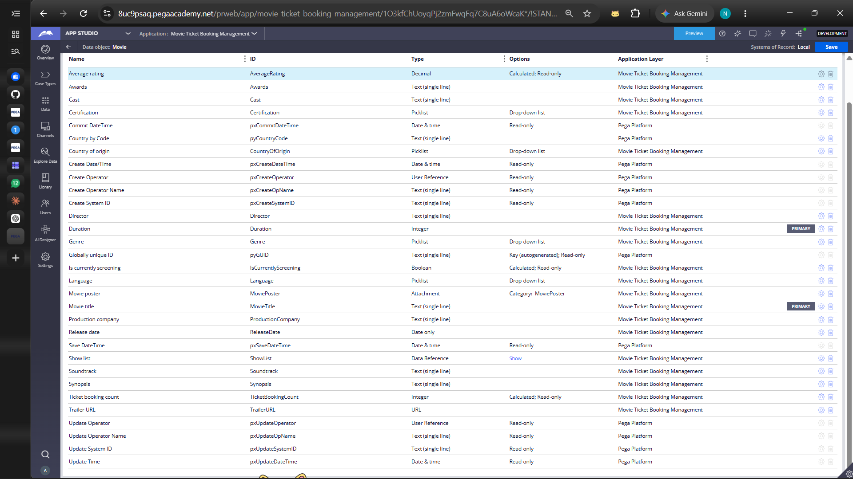
Movie data object showing fields including Genre, Movie title, Duration, Release date and the Show list reference.
What I built for this:
Created a reusable Movie data object with fields such as Movie title, Genre, Duration, Release date, Director and a Show list data reference, linked into the Movie Ticket Request case.

US-006 — Review Booking Details
What is expected: Confirmation screen shows Movie Name, Show Timing, Number of Tickets and Total Cost clearly.
Screenshot:

Show Summary Review screen displaying Movie Name, Show Date, Show Time, Ticket Quantity, Show Type and Total Cost together.
What I built for this:
Designed the Show Summary Review screen to present Movie Name, Show Date/Time, Ticket Quantity, Show Type and Total Cost in one view before the customer confirms the booking.

US-007 — Process Ticket Booking
What is expected: Booking Execution stage. Seat Numbers, Ticket ID and Booking Confirmation Status maintained.
Screenshot:

Resolved case details — Seat Numbers = A1, A2; Ticket ID = TKT-2026-001; Booking Confirmation Status = Confirmed.
What I built for this:
Configured the Process Booking stage (Lock Seats, Generate Booking ID, Update Systems, Route Booking by Show Type) which produces the final Seat Numbers, Ticket ID and Booking Confirmation Status.

US-008 — Notify Booking Confirmation
What is expected: Correspondence rule triggered on case resolution. Email includes movie, show, seat and cost details.
Screenshot:
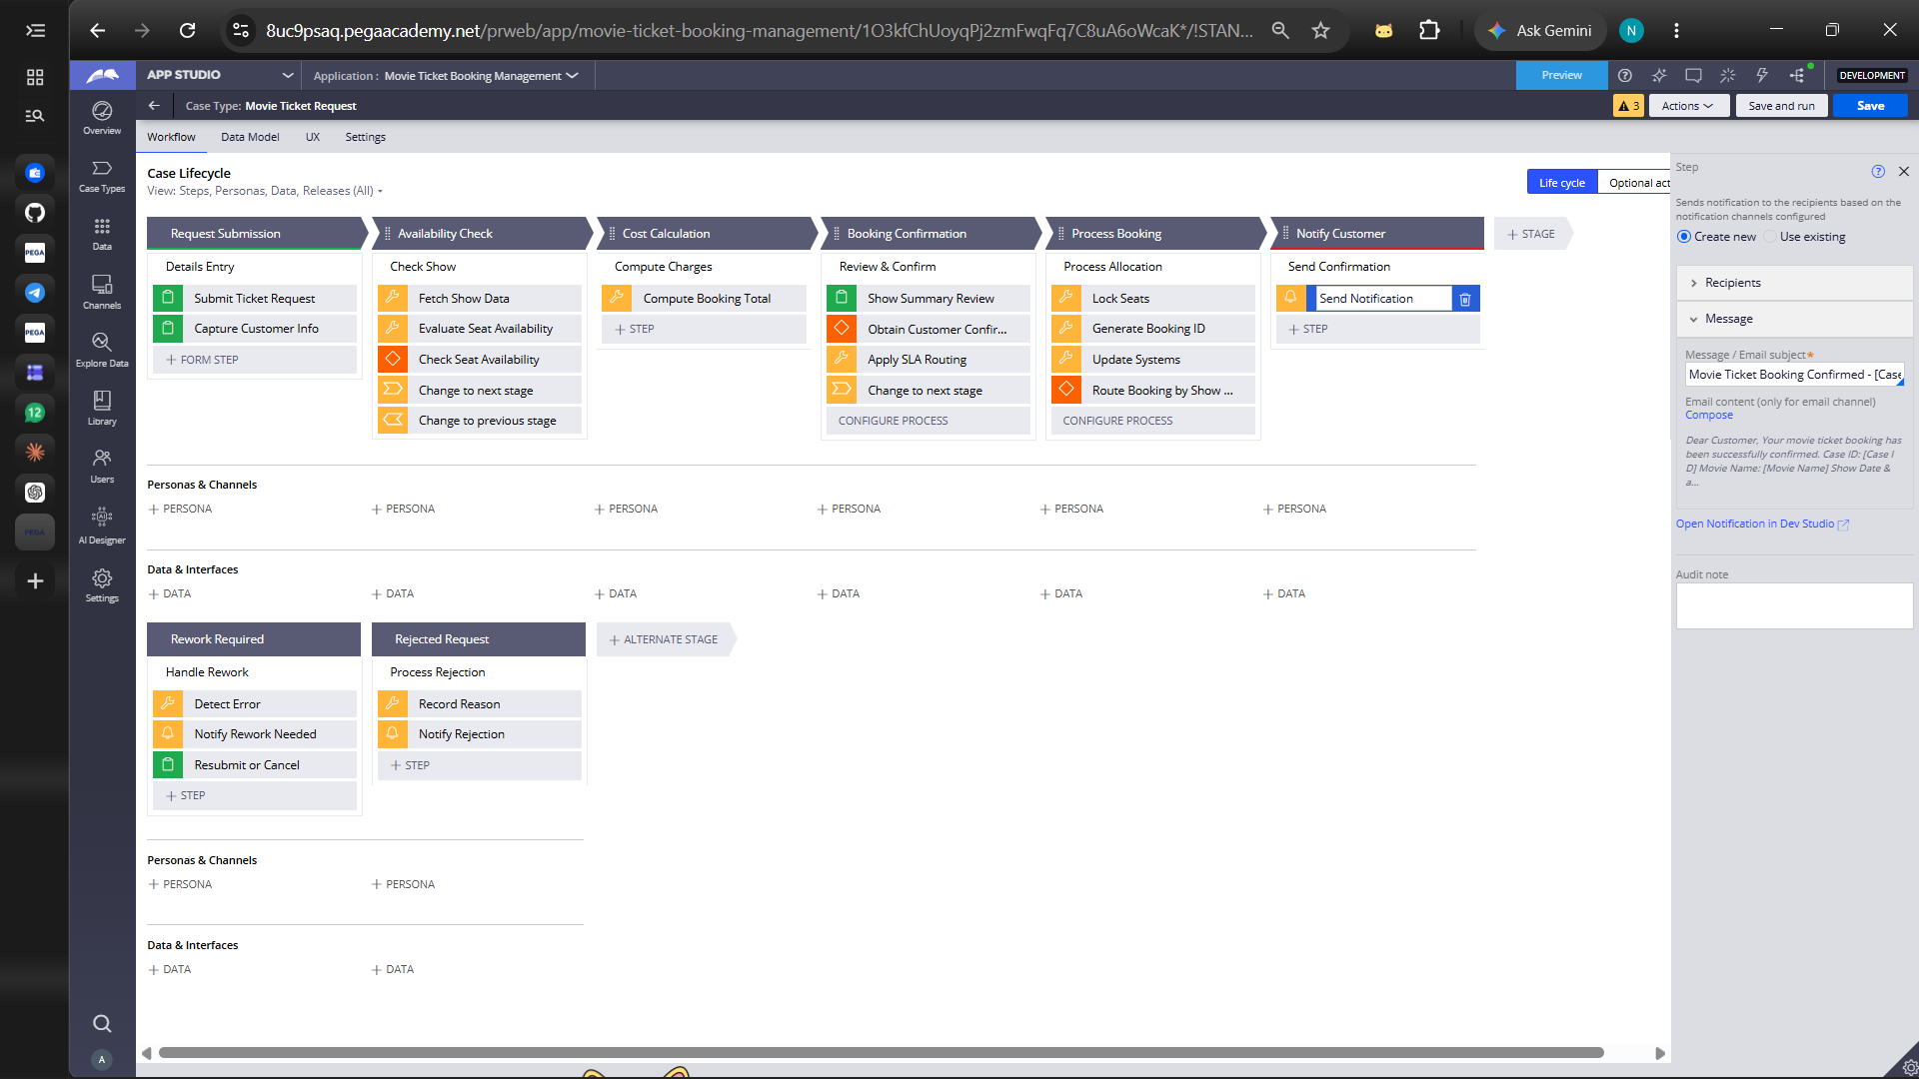
Notify Customer stage — Send Notification step with the confirmation message referencing Case ID, Movie Name and Show Date.

What I built for this:
Set up a Send Notification step in the Notify Customer stage with a confirmation message template referencing Case ID, Movie Name and Show details.

US-009 — Define Booking SLA
What is expected: SLA configured on the case type. Goal: 1 day. Deadline: 2 days. Priority increases on breach.
Screenshot:
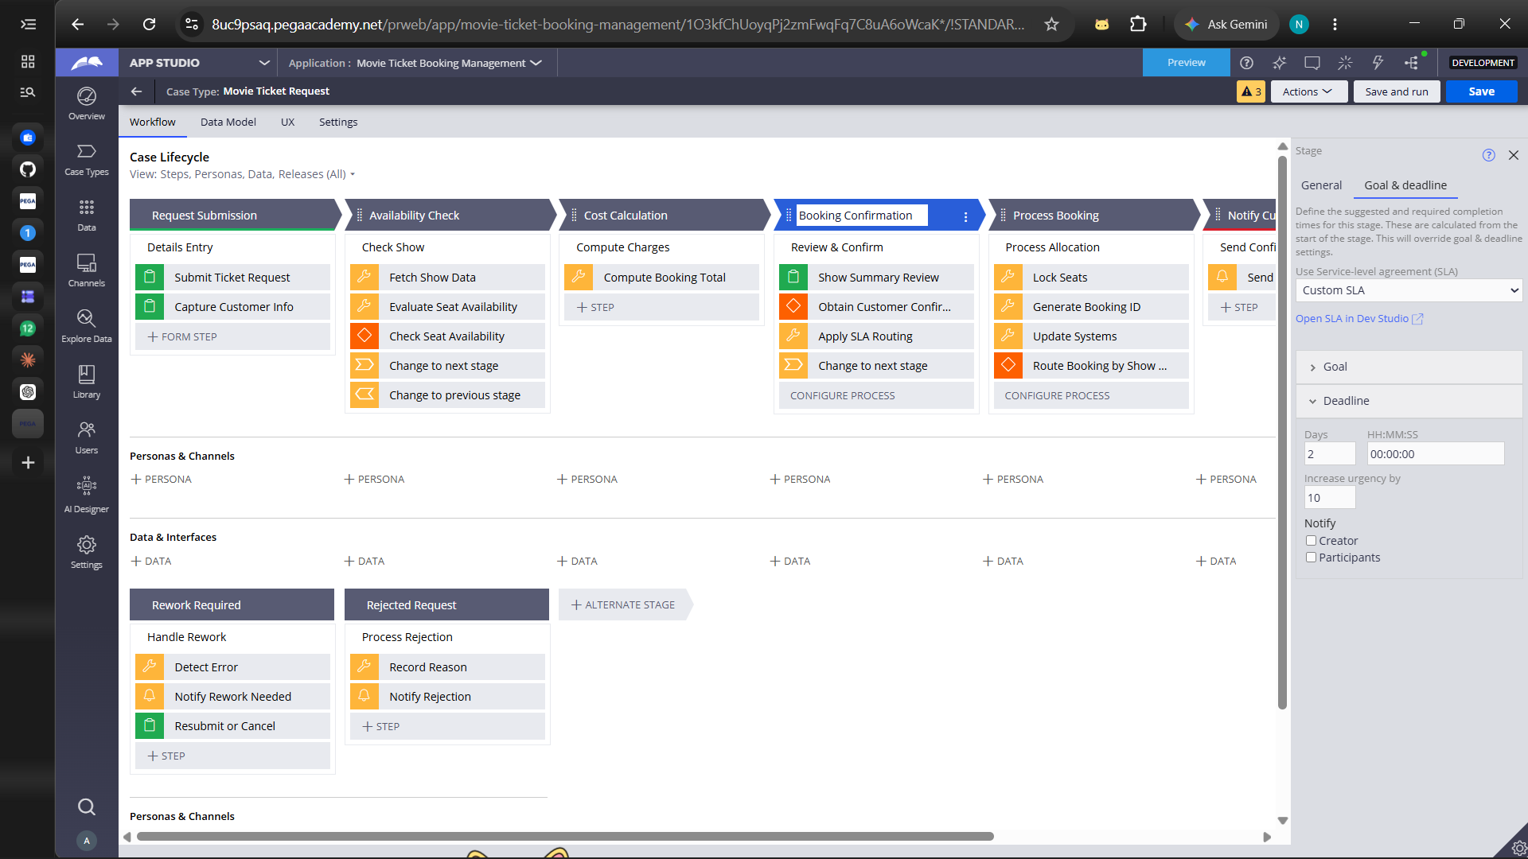
Custom SLA on the Booking Confirmation stage — Deadline = 2 Days, Increase urgency by = 10.
What I built for this:
Configured a Custom SLA on the Booking Confirmation stage with Goal = 1 Day, Deadline = 2 Days and urgency increasing by 10 on breach.

US-010 — Route by Show Type
What is expected: Routing rule or Decision Table routes to PremiumShowQueue or StandardShowQueue based on Show Type property.
Screenshot:
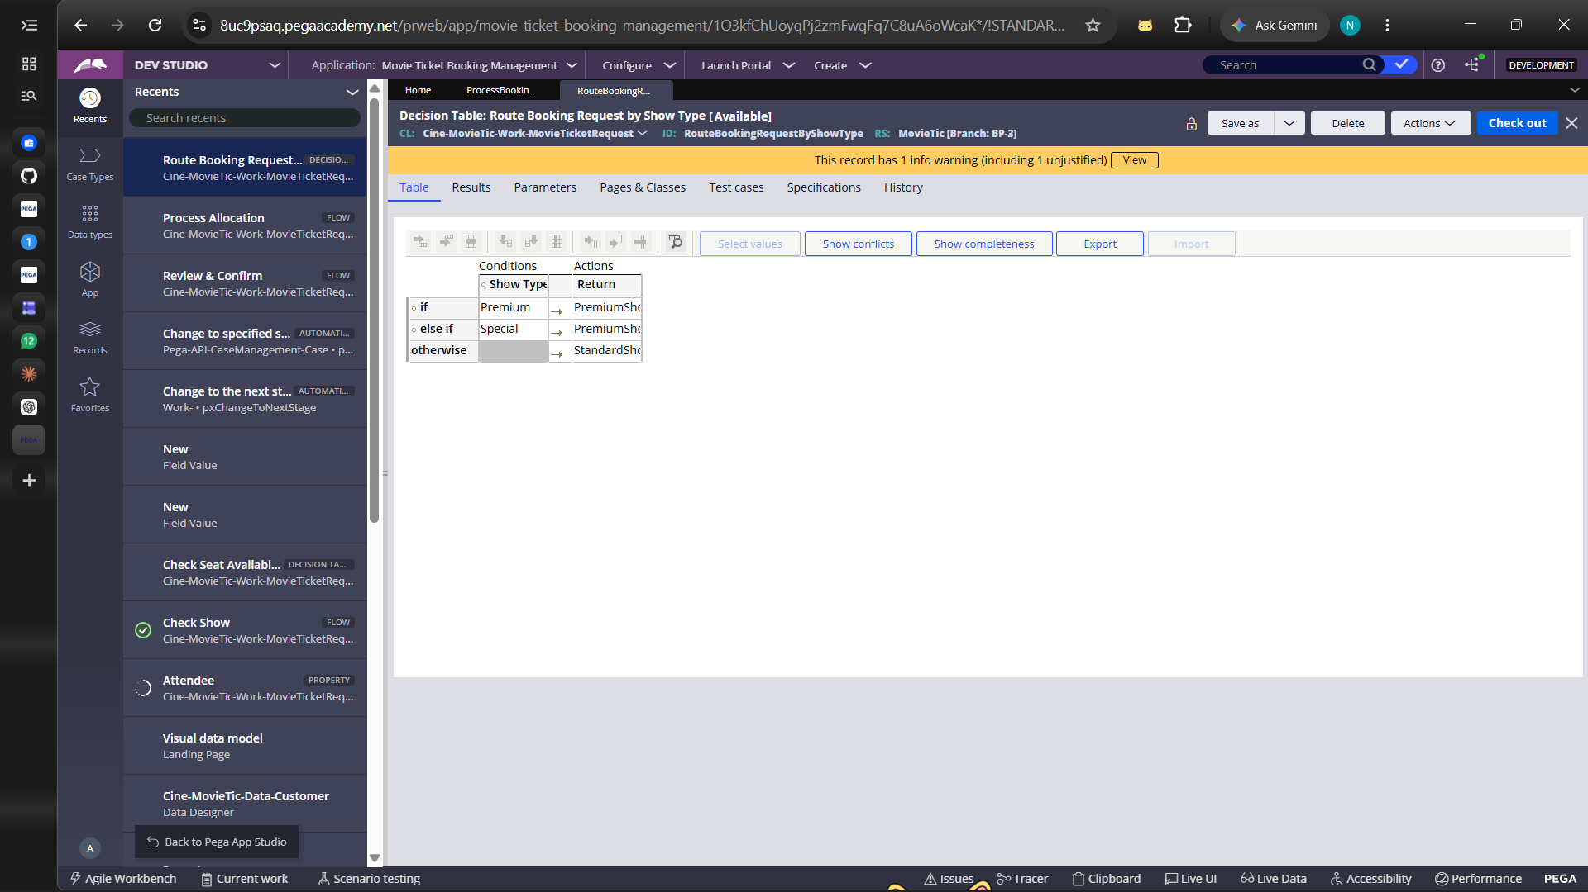
Decision Table “Route Booking Request by Show Type” — Premium → PremiumShowQueue, Special → PremiumShowQueue, otherwise → StandardShowQueue.
What I built for this:
Built the RouteBookingRequestByShowType Decision Table so Premium and Special shows route to PremiumShowQueue and all other show types route to StandardShowQueue.

Section 3 — About My Application
These answers reflect exactly what is shown in the application and screenshots.
Q1. List your stages in the order they appear in your case lifecycle.
Request Submission, Availability Check, Cost Calculation, Booking Confirmation, Process Booking, Notify Customer (with Rework Required and Rejected Request as alternate stages).
Q2. Name the data object(s) you created and the properties inside them.
Movie data object — properties include Movie title, Genre, Director, Duration, Release date, Country of origin, Certification, Language, Cast, Production company, Synopsis, Soundtrack, Trailer URL, Movie poster, Ticket booking count, Average rating and a Show list data reference.
Q3. What is the exact name and type of the rule you used to calculate Total Cost?
Rule Name: Compute Booking Total (step within the Cost Calculation stage).
Rule Type: Utility/expression step in the case lifecycle.
Properties used: Ticket Price, Ticket Quantity.
Formula used: Total Cost = Ticket Price × Ticket Quantity (e.g., $150 × 2 = $300).

Section 4 — Your Understanding
Q4. What did Blueprint generate for you, and what did you add or change yourself afterwards?
Blueprint generated the initial case type skeleton — the six-stage lifecycle (Request Submission through Notify Customer), the default steps within each stage, and the base Movie data object. I then added the specific fields on the Request Submission form, configured the Compute Booking Total step, built the Custom SLA on the Booking Confirmation stage, created the RouteBookingRequestByShowType Decision Table, and set up the Send Notification message.
Q5. Was there anything Blueprint created that you had to correct or configure further? Describe one example.
The Decision Table generated by Blueprint did not have my exact routing logic configured, so I had to manually set the conditions (Premium and Special → PremiumShowQueue, otherwise → StandardShowQueue) and verify them under Show Completeness before saving.
Q6. Explain your case flow from creation to resolution, in order.
The customer submits ticket details in Request Submission. The case then checks show and seat availability in Availability Check, calculates Total Cost in Cost Calculation, and presents a summary for confirmation in Booking Confirmation (Booking Status = Confirmed). Process Booking locks the seats, generates the Ticket ID, and routes the request by Show Type. Notify Customer then sends the confirmation message and the case resolves. If a request is rejected, it is meant to move to the Rejected Request stage, though that path was not fully tested.
Q7. Pick two design choices you made in your application and explain why you made them.
1) Decision Table for show-type routing — I implemented RouteBookingRequestByShowType as a Decision Table rather than hard-coded logic so new show types or queues can be added later without touching the flow, keeping routing rules easy to maintain.
2) Custom SLA with urgency escalation — I configured a Custom SLA (Goal 1 day, Deadline 2 days, urgency +10) on the Booking Confirmation stage so bookings nearing the deadline are automatically prioritised, reducing the risk of unconfirmed bookings.
Q8. What was the hardest part, and how exactly did you fix it?
The hardest part was configuring the Custom SLA correctly, since Goal and Deadline are set on separate tabs within the stage settings panel. I initially only set the Deadline; I went back into Goal & Deadline settings and added the Goal (1 Day) and confirmed the urgency increase value (10) so both were applied to the stage.
Q9. If the approval step was only needed when Total Cost is above a certain amount, what would you change in your application?
I would add a When condition rule that checks whether Total Cost exceeds the threshold, and use it on the 'Change to next stage' step (or a decision shape) before Booking Confirmation, so the case skips directly to Process Booking when the condition is false and only requires confirmation when Total Cost is above the limit.
Q10. List three exact rule names from your application that you personally created or modified.
1. RouteBookingRequestByShowType — Decision Table.
2. Check Seat Availability — Decision Table.
3. Custom SLA (Booking Confirmation stage) — Service Level Agreement rule.
Q11. List all personas used in your application.
The application currently runs on the default case Author/creator persona; no additional named personas were configured under Personas & Channels for any stage in the case lifecycle.
Q12. List all work queues used in your application and explain when each one is used.
PremiumShowQueue — used when Show Type is Premium or Special.
StandardShowQueue — used for all other Show Types (the 'otherwise' condition in the Decision Table).

